Switch# - enable  
Switch# - config t

Config Vlan

S1# **configure terminal**

S1(config)# **vlan 99**

S1(config-vlan)# **name Blob**

S1(config-vlan)# **exit**

S1(config)# **interface vlan99**

%LINEPROTO-5-UPDOWN: Line protocol on Interface Vlan99, changed state to down

S1(config-if)# **ip address 192.168.1.2 255.255.255.0**

S1(config-if)# **no shutdown**

S1(config-if)# **exit**

S1(config)#

S1(config)# **interface range f0/1 – 24,g0/1 - 2**

S1(config-if-range)# **switchport access vlan 99**

S1(config-if-range)# **exit**

S1(config)#

Set default gateway

S1(config)# **ip default-gateway 192.168.1.1**

Set Passoword

S1(config)# **line con 0**

S1(config-line)# **password cisco**

S1(config-line)# **login**

//S1(config-line)# **logging synchronous**

S1(config-line)# **exit**

S1(config)#

Manage mac address in switch

S1# **show mac address-table**

Add static address

S1(config)# **mac address-table static 0050.56BE.6C89 vlan 99 interface fastethernet 0/6**

S1# **clear mac address-table dynamic**

**Disable ports až na f 0/1 a f 0/6**

S1#config t

Enter configuration commands, one per line. End with CNTL/Z.

S1(config)#interface range f 0/2-5, f 0/7-24, g 0/1-2

S1(config-if-range)#shu

S1(config-if-range)#shutdown

Save the configuration.

S1# **copy running-config startup-config**

Destination filename [startup-config]? **[Enter]**

Building configuration...

[OK]

S1#

Automatic trunk port

S1(config)# **interface f0/1**

S1(config-if)# **switchport mode dynamic desirable**

Neautomaticky (musi se udelat na obou switchich)

S1(config)# **interface f0/1**

S1(config-if)# **switchport mode trunk**

**Vyhození vlany z trunku**

**c3550(config)#int fa0/2 //trunkový port**

**c3550(config-if)#switchport trunk allowed vlan remove 5-10,12**

Trunk Based interVlan routing pomocí sub-interfaců

R1(config)# **interface g0/1.1**

R1(config-subif)# **encapsulation dot1Q 1**

R1(config-subif)# **ip address 192.168.1.1 255.255.255.0**

R1(config-subif)# **interface g0/1.10**

R1(config-subif)# **encapsulation dot1Q 10**

R1(config-subif)# **ip address 192.168.10.1 255.255.255.0**

R1(config-subif)# **interface g0/1.20**

R1(config-subif)# **encapsulation dot1Q 20**

R1(config-subif)# **ip address 192.168.20.1 255.255.255.0**

R1(config-subif)# **exit**

R1(config)# **interface g0/1**

R1(config-if)# **no shutdown**

Zlatý grál

R1(config)# **no ip domain-lookup**

Hesla k terminálu a admin prostoru

R1(config)# **enable secret class**

R1(config)# **line con 0**

R1(config-line)# **password cisco**

R1(config-line)# **login**

R1(config-line)# **logging synchronous**

R1(config-line)# **exit**

R1(config)#

Na vzdaleny pristup telnet

R1(config)# **line vty 0 4**

R1(config-line)# **password cisco**

//neni treba R1(config-line)# **exec-timeout 5 0**

R1(config-line)# **transport input telnet**

R1(config-line)# **login**

R1(config-line)# **logging synchronous**

R1(config-line)# **exit**

R1(config)#

Vzdaleny pristup ssh

R1# **configure terminal**

R1(config)# **ip domain-name CCNA-lab.com**

R1(config)# **username admin privilege 15 secret adminpass1**

R1(config)# **line vty 0 4**

R1(config-line)# **transport input ssh**

R1(config-line)# **login local**

R1(config-line)# **exit**

R1(config)# **crypto key generate rsa modulus 1024**

R1(config)# **exit**

Rychlá kopypasta

no ip domain-lookup

service password-encryption

enable secret class

banner motd #Unauthorized access is strictly prohibited.#

line con 0

password cisco

login

logging synchronous

line vty 0 15

password cisco

login

exit

Loopback setup

R1(config)#int loopback 1

R1(config-if)#ip add 2.0.0.1 255.0.0.0

R1(config-if)#no shut

R1(config-if)#exit

Static routing

Router(config)# **ip route** *network-address* *subnet-mask* *exit-intf/next hop ip*

Router(config)# no **ip route** *network-address* *subnet-mask* *exit-intf/next hop ip*

*Default Route Conf*

R1(config)# **ip route 0.0.0.0 0.0.0.0 s0/0/1**

**Setup DCE serial**

R3(config)# **interface s0/0/0**

R3(config-if)# **ip address 10.1.1.2 255.255.255.252**

R3(config-if)# **clock rate 128000**

R3(config-if)# **no shutdown**

Conf RIPv2

R1(config)# **router rip**

R1(config-router)# **version 2**

**//nešiř na lokálu – to znamená passive-interface**

R1(config-router)# **passive-interface g0/1**

R1(config-router)# **network 172.30.0.0**

R1(config-router)# **network 10.0.0.0**

**Delete ip route**

R1#clear ip route 209.165.201.0

Když rozesráno, protože stejnej subnet

R1(config)# **router rip**

R1(config-router)# **no auto-summary**

R1(config-router)# **end**

R1# **clear ip route \***

**Příklad**

* + 1. Configure RIPv2 for R1.

R1(config)# **router rip**

R1(config-router)# **version 2**

R1(config-router)# **network 192.168.0.0**

R1(config-router)# **network 192.168.1.0**

R1(config-router)# **network 192.168.2.252**

R1(config-router)# **no auto-summary**

* + 1. Configure RIPv2 and a default route to the ISP on R2.

R2(config)# **router rip**

R1(config-router)# **version 2**

R2(config-router)# **network 192.168.2.252**

R2(config-router)# **default-information originate**

R2(config-router)# **exit**

R2(config)# **ip route 0.0.0.0 0.0.0.0 209.165.200.225**

Distribute my gateway of last resort

R2(config)# **router rip**

R2(config-router)# **default-information originate**

R2(config-router)# **exit**

R2(config)# **ip route 0.0.0.0 0.0.0.0 209.165.200.225**

ACL shit

//R3(config)#ip access-list standard blob

R1(config)# **ip access-list standard BRANCH-OFFICE-POLICY**

R1(config-std-nacl)# **permit host 192.168.30.3**

R1(config-std-nacl)# **permit 192.168.40.0 0.0.0.255**

R1(config-std-nacl)# **end**

R1# **config t**

R1(config)# **interface g0/1**

R1(config-if)# **ip access-group BRANCH-OFFICE-POLICY out**

**Odebrání**

**R1(config)#ip access-list standard BRANCH-OFFICE-POLICY**

**R1(config-std-nacl)#no 40 deny all**

**//cislo nemusi byt, cislo je radek v show access-list**

**Druhá verze //remark – prejmenování**

R3(config)# **access-list 1 remark Allow R1 LANs Access**

R3(config)# **access-list 1 permit 192.168.10.0 0.0.0.255**

R3(config)# **access-list 1 permit 192.168.20.0 0.0.0.255**

R3(config)# **access-list 1 deny any**

R3(config)# **interface g0/1**

R3(config-if)# **ip access-group 1 out**

**Nastavení statický NAT**

Gateway(config)# **ip nat inside source static 192.168.1.20 209.165.200.225**

Issue the **ip nat inside** and **ip nat outside** commands to the interfaces.

Gateway(config)# **interface g0/1**

Gateway(config-if)# **ip nat inside**

Gateway(config-if)# **interface s0/0/1**

Gateway(config-if)# **ip nat outside**

**show ip nat**

**Dynamický NAT**

Gateway(config)# **access-list 1 permit 192.168.1.0 0.0.0.255**

Gateway(config)# **ip nat pool public_access 209.165.200.242 209.165.200.254 netmask 255.255.255.224**

Gateway(config)# **ip nat inside source list 1 pool public_access**

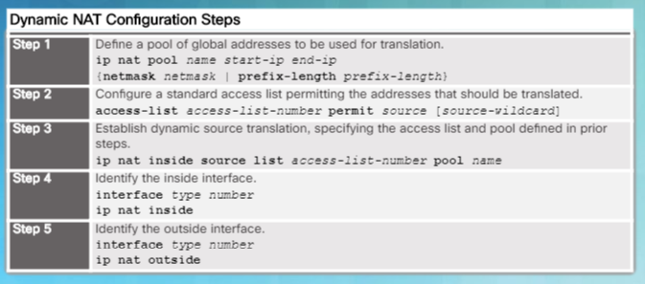

**Místo pool name se dá použít Interface označení (např s0/0/1)**

**PAT vznikne, že se přidá magicé slovíčko overload**

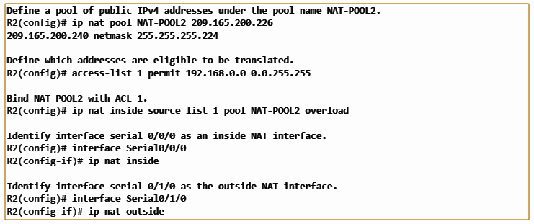

Nějaký kouzla s DHCP, kdyby šlo do tuhýho

Nastavený jako relay – přeposílá dhcp dotazy dál

R1(config)# **interface g0/0**

R1(config-if)# **ip helper-address 192.168.2.254**

R1(config-if)# **exit**

R1(config-if)# **interface g0/1**

R1(config-if)# **ip helper-address 192.168.2.254**

**Už samotný dhcp server**

R2(config)# **ip dhcp excluded-address 192.168.0.1 192.168.0.9**  
R2(config)# **ip dhcp excluded-address 192.168.1.1 192.168.1.9**R2(config)# **ip dhcp excluded-address 192.168.1.254**  
R2(config)# **ip dhcp pool R1G1**  
R2(dhcp-config)# **network 192.168.1.0 255.255.255.0**  
R2(dhcp-config)# **default-router 192.168.1.1**  
R2(dhcp-config)# **dns-server 209.165.200.225**  
R2(dhcp-config)# **domain-name ccna-lab.com**  
R2(dhcp-config)# **lease 2**  
R2(dhcp-config)# **exit**R2(config)# **ip dhcp pool R1G0**  
R2(dhcp-config)# **network 192.168.0.0 255.255.255.0**  
R2(dhcp-config)# **default-router 192.168.0.1**  
R2(dhcp-config)# **dns-server 209.165.200.225**  
R2(dhcp-config)# **domain-name ccna-lab.com**  
R2(dhcp-config)# **lease 2**

